The use of gametes from donors who have undergone expanded carrier screening: a guidance for UK practice
Mariano Mascarenhas¹, Valerie Shaikly^{2*}, Anneke Lucassen³, Debra Bloor⁴, Saffron Townsend⁵, Karen Thompson⁶ and Harish Bhandari^{7**}on behalf of the BFS.

- Medical Director, Care Fertility Leeds, LS14 6UH
- Consultant Reproductive Clinical Scientist, Fertility Genetics.
- Professor of Genomic Medicine, University of Oxford
- Director of Governance, Care Fertility, Nottingham NG8 6PZ
- TBA
- Lead Embryologist, Genus Fertility, Edinburgh
- Consultant in Reproductive Medicine and Surgery, Leeds Centre for Reproductive Medicine, Leeds Teaching Hospitals NHS Trust, Leeds LS14 6UH
*Corresponding author
** Supervising author

Abstract
Expanded carrier screening (ECS) is increasingly offered within assisted reproductive technologies (ART), particularly as a component of donor gamete selection. As genomic testing options rapidly evolve, the complexity of interpreting ECS results presents significant challenges for donor gamete recipients and the healthcare professionals supporting them. At the same time, regulatory frameworks and professional guidelines have not kept pace with these technological developments, resulting in gaps between clinical practice and formal guidance. This paper aims to summarise current practice, highlight emerging issues arising from the integration of ECS into gamete selection, and provide recommendations to facilitate informed decision-making

Keywords

Expanded carrier screening, variant, autosomal recessive, carrier frequency, donor gamete, recipient, assisted reproductive technologies (ART)

Background:
Carrier screening for autosomal recessive (AR) conditions is the practice of screening individuals to assess whether they are carriers of a pathogenic genetic variant or allele. When both gamete providers carry pathogenic variants in the same gene, there is a 25% (1 in 4) risk that their child will be affected by the recesive condition associated with the gene (Miko, 2008). There are thousands of AR conditions with varying frequencies across populations, and carrier screening tests have been developed as different panels depending on the clinical context. The practices and policies around using these tests in donor banks vary widely.

The HFEA Code of Practice (HFEA 2023) recommends that gamete donors should be screened in accordance with professional guidance produced by the relevant professional bodies. Current and proposed UK professional body guidelines (Clarke et al. 2019 and 2026 in press) stipulate that those with an AR condition should not generally be accepted as gamete donors, and that the potential donor should ordinarily not be heterozygous for an autosomal recessive gene known to be prevalent in the donor’s ethnic background. We argue that this is not logical, particularly since all individuals are likely carriers of at least one AR condition if screening is extensive enough. Further, this poses a barrier to the use of donors who have had ECS and have been identified as carriers, and is not logical for those AR conditions where carrier status holds no health implications. Technological advances over the last decade have made genome-wide sequencing affordable, enabling a pan-ethnic approach, expanding carrier screening to include many known AR conditions, regardless of population prevalence (van der Hout et al., 2016; Arjunan, 2022).

Current landscape
The current screening of gamete donors for heritable conditions has evolved without a cohesive framework and includes family history questionnaires and some genetic screening (NHS Scotland 2020, Clarke et al. 2019). The HFEA Code of Practice requires an assessment of the risk of transmission of inherited conditions known to be present in the family, and that information on the associated condition and available measures to mitigate those risks is clearly explained to the recipient.

Professional body guidance recommends karyotype testing for chromosome abnormalities and screening of genes associated with AR diseases for cystic fibrosis, thalassemias and sickle cell for all donors (Clark 2026 in press) and other conditions known to be prevalent in the donor's ethnic background, such as glucose-6-phosphate dehydrogenase deficiency in Mediterranean populations and Tay-Sachs disease in Jewish people of Eastern European descent. As described previously, the guidance specifies that donors should ordinarily not be carriers of AR conditions and that donors who screen positive for a recessive condition can be accepted under exceptional circumstances. (e.g., for a known donation) after all parties are fully informed, the view of an appropriately qualified clinical geneticist is obtained and where full records of the discussions are kept (Clarke et al. 2019 and 2026 in press). The guidance update does not recommend ECS but acknowledges that donor banks are implementing ECS, which can lead to the requirement for recipient testing for donor matching. As donor sperm is increasingly purchased from banks where donors have undergone ECS, it is important that guidance for clinics and patients is available.

It could be argued that ECS may not be clinically beneficial to the average gamete recipient, as many conditions included in expanded carrier screening (ECS) (Rowe and Wright, 2019) have a low prevalence in the general population. The co-carrier risk (the risk of both recipient and donor being carriers of pathogenic variants in the same gene) for conditions meeting clinical utility criteria varies according to the genes included, the variants reported and categorisation of disease severity, but is estimated to be in the region of 2- 2.6% (Westemeyer et al., 2020, Kirk et al 2024. Lee et al 2025). ECS is generally not included in treatment pathways using autologous gametes, A recent ESHRE ethics committee opinion advised that ECS could be offered to all ART patients with responsible use that is proportionate, ethically justified, and sensitive to professional responsibility involved so patients are supported rather than pressured while undergoing assisted reproduction. (de Wert et al., 2021). Expanded carrier screening is also increasingly considered (Kirk et al. 2021) in preconception screening for non-assisted conceptions ("Committee Opinion No. 690 Summary," 2017), with the American College of Medical Genetics and Genomics (ACMG) recommending screening all couples planning a pregnancy with a standardised pan-ethnic ECS panel of 113 genes (Gregg et al., 2021).

Many donor banks are now including ECS results within a gamete donor's profile, and as panels expand, more donors are found to be carriers, sometimes of very rare conditions. As outlined previously, professional guidelines suggest that carriers of genetic conditions should not ordinarily be accepted as donors. It can be argued that this has no medical basis in most circumstances. Furthermore, such exclusion reduces the number of donors who are eligible to donate, making access to donor gametes more limited and potentially increasing cost (Payne et al. 2021).

Materials and methods

This paper was written in response to the current clinical dilemma of ECS reporting by donor banks. Multidisciplinary input was sought from a representative working group comprising clinicians in reproductive medicine, embryology, reproductive science, clinical genetics, and a lay stakeholder. The group considered existing UK professional body guidance, international recommendations, and the evolving practices of donor banks regarding ECS.
A review of relevant literature was undertaken, including existing guidelines, consensus statements, and recent studies evaluating the implementation and outcomes of ECS in donor and recipient populations. While this was not a formal systematic review, the group drew upon key peer-reviewed publications and current UK regulatory frameworks to inform the guidance.
The group also examined case examples from clinical practice to understand challenges experienced by recipients when ECS results were provided as part of the donor profile. These examples highlighted areas where clearer guidance and consistent practice are needed.
Where evidence was limited or conflicting, a consensus-based approach was adopted. Each recommendation was discussed within the group, with the aim of ensuring that any proposed practice is clinically meaningful, ethically justified, and proportionate within the UK regulatory context.
The guidance was drafted iteratively, with all authors contributing to revisions. The final version was reviewed and approved by all members before submission, ensuring that the document reflects multidisciplinary consensus.

Scope of the Guidance
This guidance focuses on the use of gametes from donors who have undergone expanded carrier screening (ECS). It addresses the interpretation and communication of ECS results and approaches for donor–recipient selection to support informed decision-making in the context of extended carrier screening. It should also be recognised that a residual risk of recessive conditions still remains following ECS and reciprocal screening. The guidance does not address autosomal dominant conditions or genetic variants arising de novo in the egg or sperm. Clinics should ensure that the limitations of ECS are communicated. This document is intended for clinicians, embryologists, reproductive scientists, genetic counsellors, and other professionals involved in recipient care. It also provides information relevant to fertility counsellors and regulators.
The guidance applies to the use of donor sperm, donor eggs, and double donation where donors have undertaken.ECS. It does not cover ECS options for individuals undergoing assisted conception with partner gametes, nor does it address prenatal or newborn screening programmes.

Guidance for clinicians:

The place of ECS within current donor screening protocols
Expanded carrier screening of donors is not mandatory; however, recipients frequently request guidance from their clinic regarding the interpretation and implications of carrier screening results for themselves and their children. An information sheet, developed as part of this paper, is available in Appendix 1 for clinics to adapt for their use.

Recipients should be guided to understand the extent of genetic screening for a selected donor. For example, the number of AR conditions screened for, and that dominantly inherited adult-onset diseases are not tested but assessed via a review of the donor's available family history. They should also be made aware that although ECS can be used for all donors irrespective of their ancestral background, much of the data in available ECS panels has been obtained from populations of northern European ancestry (GWASdiversitymonitor.com), which means that considerably less is known about the frequency or pathogenicity of variants in other populations (Arjunan 2022).

Understanding and interpreting ECS reports:

Variation in screening protocols and information provided by donor banks.
The more genes are tested, the more likely a person will be found to be a carrier of an autosomal recessive genetic condition (Greg et al., 2021). Some donor banks employ small panels (varying from 3 to 37 genes) and exclude any carriers from the donation programme. Others use larger panels (283 to 500+ genes) and accept donors who are found to be carriers. Some donor banks curate in-house prevalence and severity limits for conditions, rejecting certain carrier donors and accepting others. Information on such criteria is not always easily accessible to recipients or healthcare professionals.

Where ECS results are shared with the recipient by a donor bank, the information provided ranges from declaring the carrier status in a particular gene to a full ECS report on all genes screened. Some donor banks report ECS results but do not provide personalised guidance on the implications of the results, while simultaneously asking potential recipients or clinics to sign a document stating that sufficient information from a suitable professional has been provided to demonstrate an understanding of carrier status and reproductive risk. Other donor banks may offer a genetic matching service for carrier status (often for an additional fee), but do not disclose the carrier status of either the donor or the recipient.

Variation of genes included in ECS panels
The provision of ECS often operates on a user-pay basis, with donor banks free to select ECS test providers according to commercial considerations or perceived competitive advantages, rather than on the basis of standardised clinical or ethical criteria. Most panels consider the carrier frequency of the gene variant in the population and the severity of the associated condition. Panels can include gene variants with carrier frequencies ranging from 1 in 4 to greater than 1 in 500 people (Greg et al., 2021). For certain conditions, variants that result in milder forms of the condition or those with variable penetrance or expressivity may be reported. In summary, ECS panels exhibit substantial differences between the genes included at the time the panel was established and the reporting of milder variants.

Variation in reported carrier frequencies and residual risks quoted by ECS providers.
To consider a recipient's personalised reproductive risk to use a donor with known carrier status, the probability of the recipient also being a carrier should be estimated. Since the carrier frequency for many rare recessive conditions is often unknown, providing accurate personalised risk estimates can be challenging and often falls outside the expertise and remit of most fertility clinics. Table 1 illustrates some of the variability in risk estimates reported by commercial providers in the carrier frequency tables that accompany ECS tests. Currently, donor banks are not mandated to share genetic test reports, disclose the commercial ECS panel used, or provide a population carrier frequency for detected conditions, all of which would assist a recipient to make informed decisions.
Even when such information is shared, the variability in population-based carrier frequencies suggests that using data from a single commercial provider, ie the provider used to test the donor, may not accurately reflect the reproductive risk for a recipient.
Recommendation
Potential recipients should be provided with information and support in understanding recessive inheritance, the extent of donor testing, and whether a carrier status is associated with the donor. Information should include the limitations of testing and residual risks. An information sheet, adaptable for clinic use, is available in Appendix 1.

Clinics should advise recipients that their genetic ancestry could influence the appropriateness of the ECS gene panel included in the carrier screening of a donor

Donor banks should provide details on the population carrier frequencies of conditions carried by a donor to aid patient counselling and facilitate reproductive risk assessment.

Table 1: Examples to show inter-provider variation for carrier frequency estimates for the same gene by self-reported ethnicity.
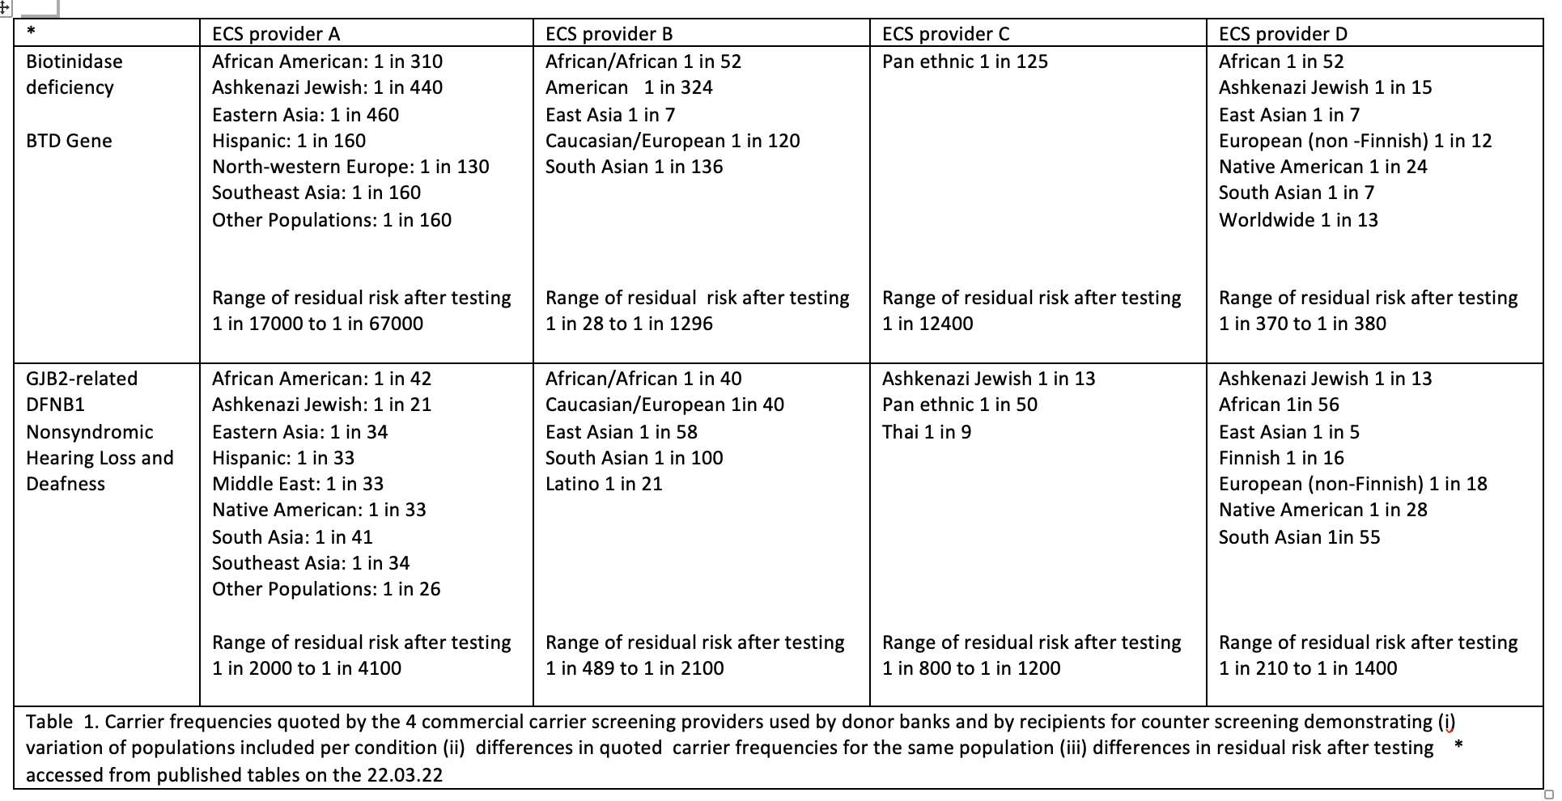

Psychological impact for gamete recipients; parity with those having treatment with their own gametes

Fertility treatment with donor gametes can be an emotional and complex process, and the information provided should match the recipient's needs and consider their personal risk perception and anxiety. The discussion between clinical staff and a recipient should frame the understanding that any conception involves some degree of genetic risk and that a level of screening may be recommended according to their individual family history or ancestry. ECS is intended to reduce the generally low baseline reproductive risk in the general population for AR conditions. However, knowledge of an AR recessive carrier status for a donor places additional steps and considerations on recipients. Recipients may wish to take time to seek further advice from their clinic or a suitably qualified professional to understand their options before proceeding with a donor. The information sheet in Appendix 1 may be helpful for such discussions.

Recommendation
Potential recipients should have the option to choose the level of ECS provision for their donor selection, with carrier screening reported at a level acceptable to them. As donor ECS results, once generated, usually form part of the donor profile, choice, could be facilitated through access to donor banks with differing ECS policies, including those where ECS is not reported, where screening is limited, or where broader ECS panels are used.

Recipient screening and genetic counselling
An option to maintain parity between donor gamete recipients and those having treatment with their own gametes would be to apply the criteria advised for screening of partners using autologous gametes, where one partner is a known carrier of a recessive genetic condition.

In the UK, current NHS guidelines suggest the need for carrier screening if a reproductive partner or family member is a known carrier and the carrier frequency of the condition is up to 1 in 70 in the relevant population(s) of the patient to be tested (NHS genomic test directory, October 2021). In other words, carrier screening is advised when one partner is a known carrier, and the other partner’s estimated carrier frequency is ≥ 1 in 70 for the same condition. As an example, if a donor is a carrier, and the population prevalence risk of the condition is 1 in 100, the risk of a child being born with that condition (in the absence of screening for the recipient) would be 0.25% (1 in 100 divided by 4). For a condition with a 1 in 70 prevalence, the risk for the child would be 0.36% (1 in 70 divided by 4).

Recommendation
Genetic information arising from ECS should be available to all recipients. Where the carrier prevalence of the condition (or conditions) that the donor is a carrier of is at or more common than 1 in 70 in the relevant population of the recipient, options for testing to check the recipient is not a carrier of the same condition should be offered with appropriate genetic counselling..

Considerations for Information Provision
Potential recipients should have access to the advice and genetic testing options they may require from a suitably trained professional (such as genetic counsellors, specialist clinicians and clinical scientists), understanding that this may have cost implications and could delay time to treatment. Recipients and clinics should ensure that if a recipient wishes to screen for AR conditions, the testing is undertaken by an accredited laboratory using a validated test supported by a suitably qualified professional. Individuals should be informed that their residual risk after testing may vary depending on the provider selected for their testing and that the findings could have implications for their wider family.

Recommendations
Clinics should be able to provide access to in-house or external professionals who can help recipients understand their personalised carrier risk for using a donor who has been identified as a carrier, to understand options such as:
Accepting the estimated reproductive risk and proceeding to their treatment pathway

Selecting an alternative donor who has tested negative on a particular ECS panel

Selecting an alternative donor who has had ECS.
Undertaking suitable screening for the condition(s) the donor is a carrier of

Additional considerations

Consideration for the child's reproductive future
A child conceived using gametes from a donor who carries an AR condition will have a 50% chance of being a carrier. Although carrier screening is not typically offered in childhood, individuals may wish to consider carrier screening when they reach reproductive age, taking into account the screening options available at that time and their own reproductive plans.

Reconsideration of the status of donors diagnosed as a carrier of an AR condition after the birth of an affected child
Current practice includes surveillance for congenital anomalies and disabilities in children conceived using donor gametes, and in the event of an inherited condition being suspected, genetic investigation may follow. Some donor banks may restrict or require additional consent for future use if the investigation reveals that the donor is a carrier of an AR condition associated with the adverse outcome. This appears inconsistent with the practice of permitting a recipient to choose a donor who has been reported as being a carrier based on ECS from the outset.

Scenarios where understanding a carrier status can be complex:
For some recessive conditions, carriers may experience mild symptoms or be at an increased risk of certain health conditions. In these situations, the risk-benefit ratio of allowing a donor who is a carrier to donate becomes complex, as 50% of offspring would also be carriers and may manifest symptoms.

Furthermore, a recipient's risk for some recessive conditions may depend on the specific variants identified and the inclusion criteria for the ECS reporting. Specific gene variants can pose variable risks depending on their penetrance (the likelihood that a variant will result in clinical disease) and on interactions with alterations in other genes, as seen in haemoglobinopathies, or for variants in the same gene, for example, the gene associated with cystic fibrosis and classic vs non-classic forms of congenital adrenal hyperplasia. Patients should receive appropriate advice for specific variants where relevant to the health for a child.

X-linked conditions tend to manifest in males since they only have one X chromosome. Females may carry a condition on one of their two X chromosomes and experience mild or no symptoms. Some ECS panels include X-linked conditions for all donors; however, this is more relevant for oocyte donors.

Conveying the limitations of an 'ECS screened' donor
Congenital anomalies or congenital disabilities may still occur in children conceived using a donor who has undergone carrier screening at a frequency similar to that expected in the general population. Recipients should be aware that ECS screening does not eliminate all risks. Recipients should have access to appropriate prenatal and newborn screening information where applicable.

A negative ECS result for a donor is limited by the genes on the panel and variants reported by the ECS provider. In addition to specific conditions, there are nuances for residual risk due to the complexity of genes and or the chromosomal location of variants. For example, up to 4% of spinal muscular atrophy carriers may receive a false negative result (with a higher proportion in individuals of sub-Saharan descent) as they have two copies of SMN1 on one chromosome and a deletion on the other chromosome (a [2+0] genotype) (Prior 2000).

Consideration of preimplantation genetic testing of monogenic disease (PGT-M)
If both the donor and the recipient are found to be carriers of the same condition, recipients would typically choose a different donor. PGT-M may, be a possible option for HFEA-approved conditions where risk becomes evident after a live birth of an affected child and a recipient wishes to use the same donor for sibling conception. However, this is likely to depend on the availability and consent of the donor for their DNA to be used for PGT-M analysis.

Summary of recommendations
Understanding and interpreting ECS reports | Potential recipients should be provided with information and support in understanding recessive inheritance, the extent of donor testing, and whether a carrier status is associated with the donor. Information should include the limitations of testing and residual risks. An information sheet, adaptable for clinic use, is available in Appendix 1.  Clinics should advise recipients that their genetic ancestry could influence the appropriateness of the ECS gene panel included in the carrier screening of a donor  Donor banks should provide details on the population carrier frequencies of conditions carried by a donor to aid patient counselling and facilitate reproductive risk assessment.
Psychological impact for gamete recipients; parity with those having treatment with their own gametes | Potential recipients should have the option to choose the level of ECS provision for their donor selection, with carrier screening reported at a level acceptable to them. As donor ECS results, once generated, usually form part of the donor profile, choice, could be facilitated through access to donor banks with differing ECS policies, including those where ECS is not reported, where screening is limited, or where broader ECS panels are used..
Recipient screening and genetic counselling | Genetic information arising from ECS should be available to all recipients. Where the carrier prevalence of the condition (or conditions) that the donor is a carrier of is at or more common than 1 in 70 in the relevant population of the recipient, options for testing to check the recipient is not a carrier of the same condition should be offered with appropriate genetic counselling.
Considerations for information provision | Clinics should be able to provide access to in-house or external professionals who can help recipients understand their personalised carrier risk for using a donor who has been identified as a carrier, to understand options such as:  Accepting the estimated reproductive risk and proceeding to their treatment pathway  Selecting an alternative donor who has tested negative on a particular ECS panel  Selecting an alternative donor who has had ECS.  Undertaking suitable screening for the condition(s) for which the donor is a carrier.

Recommendations for collaboration and training
- Review and implementation of current ECS guidelines are required to ensure consistency of methodology and availability of transparent information for professionals and patients.
- Carrier frequencies provided by providers for ECS are variable and not always consistent across different population groups. Collaboration to collate a central reference resource would bring benefits.
- Genomics and genomic counselling are included in the Reproductive Science Scientist Training Programme (STP) curriculum. This could provide an opportunity for clinical scientists to receive training for supporting recipients. Professional bodies could run a training course for clinicians and clinical scientists to impart the essentials for providing information surrounding genetics for recipients of gamete donation.

Acknowledgements
We gratefully acknowledge the input of Mark Wilcox in the scoping stage and the input of Abha Maheshwari in the draft stage of this paper.

References
Arjunan, A.; Darnes, D.R.; Sagaser, K.G.; Svenson, A.B. Addressing Reproductive Healthcare Disparities through Equitable Carrier Screening: Medical Racism and Genetic Discrimination in United States' History Highlights the Needs for Change in Obstetrical Genetics Care. Societies 2022, 12, 33. https://doi.org/10.3390/soc12020033

Clarke H Shona Harrison, Marta Jansa Perez & Jackson Kirkman- Brownon behalf of the Association of Clinical Embryologists, the Association of Biomedical Andrologists, the British Fertility Society, and the British Andrology Society. (2019): UK guidelines for the medical and laboratory procurement and use of sperm, oocyte and embryo donors (2019), Human Fertility, DOI: 10.1080/14647273.2019.1622040

Clarke H, Martins da Silva S, Perez MJ, Mackie N, Barber T, Kirkman-Brown J,. Guidelines for the Medical and Laboratory Procurement and Use of Sperm, Oocyte and Embryo Donors (2026) Association of Reproductive and Clinical Scientists British Fertility Society British Association for Sexual Health and HIV British HIV Association
In press Human Fertility, RBMO.

Committee Opinion No. 690 Summary: Carrier Screening in the Age of Genomic Medicine
Obstet Gynecol 2017;129:595–59 6.

de Wert G, van der Hout S, Goddijn M, et al. The ethics of preconception expanded carrier screening in patients seeking assisted reproduction [published correction appears in Hum Reprod Open. 2021 Apr 17;2021(2):hoab014]. Hum Reprod Open. 2021;2021(1):hoaa063. Published 2021 Feb 12. doi:10.1093/hropen/hoaa063

Gregg AR, Aarabi M, Klugman S, Leach NT, Bashford MT, Goldwaser T, Chen E, Sparks TN, Reddi HV, Rajkovic
A, et al. Screening for autosomal recessive and X-linked conditions during pregnancy and preconception: a practice
resource of the American College of Medical Genetics and Genomics (ACMG). Genet Med 2021;23:1793–1806.
Nature Publishing Group.

HFEA code of Practice Avialable at: https://www.hfea.gov.uk/media/2565/hfea-draft-code-of-practice-9th-edition-consultation-version.pdf Accessed on 21.2.2022

Edwin P. Kirk, et al., (2024) Nationwide, Couple-Based Genetic Carrier Screening. N Engl J Med 2024; 391:1877-1889 VOL. 391 NO. 20 DOI:10.1056/NEJMoa2314768

Kirk, E.P., Ong, R., Boggs, K. et al. Gene selection for the Australian Reproductive Genetic Carrier Screening Project ("Mackenzie's Mission"). Eur J Hum Genet 29, 79–87 (2021). https://doi.org/10.1038/s41431-020-0685-x

Lee E, Orton K, Kwan E, Faga C, Le T, Shaheen R, Nair V, Cliffe S. Couple-Based Carrier Screening: How Gene and Variant Considerations Impact Outcomes. Genes (Basel). 2025 May 30;16(6):671. doi: 10.3390/genes16060671. PMID: 40565563; PMCID: PMC12192196.

Miko, I. (2008) Gregor Mendel and the principles of inheritance. Nature Education 1(1):134

NHS genomic test directory Oct 2021 R246 Carrier testing at population risk for partners of known carriers of nationally agreed autosomal recessive disorders
accessed:at ://www.england.nhs.uk/wp-content/uploads/2018/08/rare-and-inherited-disease-eligibility-criteria-v2.pdf

HFEA code of Practice Avialable at: https://www.hfea.gov.uk/media/2565/hfea-draft-code-of-practice-9th-edition-consultation-version.pdf Accessed on 21.2.2023
Lazarin GA, Haque IS, Nazareth S, Iori K, Patterson AS, Jacobson JL, Marshall JR, Seltzer WK, Patrizio P, Evans
EA, et al. An empirical estimate of carrier frequencies for 400+ causal Mendelian variants: results from an ethnically
diverse clinical sample of 23,453 individuals. Genet Med 2013;15:178–186.

NHS genomic test directory Oct 2021 R246 Carrier testing at population risk for partners of known carriers of nationally agreed autosomal recessive disorders
accessed: https://www.england.nhs.uk/wp-content/uploads/2018/08/rare-and-inherited-disease-eligibility-criteria-v2.pdf

NHS Scotland, Guidance for Gamete donation 2020. Available at https://www.fertility.scot/resource/guidance-for-gamete-donation-in-nhs-scotland-professionals/ Accessed on 21.02.2022

Payne R, Skytte A B, Harper J C., The use of expanded carrier screening of gamete donors, Human Reproduction, Volume 36, Issue 6, June 2021, Pages 1702–1710, https://doi.org/10.1093/humrep/deab067
Prior TW, Leach ME, Finanger EL. Spinal Muscular Atrophy. 2000 Feb 24 [Updated 2024 Sep 19]. In: Adam MP, Feldman J, Mirzaa GM, et al., editors. GeneReviews® [Internet]. Seattle (WA): University of Washington, Seattle; 1993-2025.
Rowe C., et al. Expanded universal carrier screening and its implementation within a publicly funded healthcare service
Journal of Community Genetics volume 11, pages 21–38 (2020)

Shaikly V, Sage K, Callum P SP6.4 Evaluation of commercially reported pre and post-test carrier screening risks in ART patients: Caveat emptor? Available at: https://fertilityconference.org/wp-content/uploads/2021/01/Fertility-2021-Abstract-book_with-deleted-ones.pdf Accessed on 21.02.2022

Westemeyer M, Saucier J, Wallace J, Prins SA, Shetty A, Malhotra M, Demko ZP, Eng CM, Weckstein L,
Boostanfar R, et al. Clinical experience with carrier screening in a general population: support for a comprehensive
pan-ethnic approach. Genet Med 2020;22:1320–1328. Nature Publishing Group.

Appendix 1: Information for recipients for carrier screening and expanded carrier screening of donors
Genes are instructions in our DNA that help our bodies grow and function. We usually inherit one copy of each gene from a sperm and one from an egg, so we have two copies. Everyone has many genetic differences. Most do not affect health. However, some changes can stop a gene from working as it should.
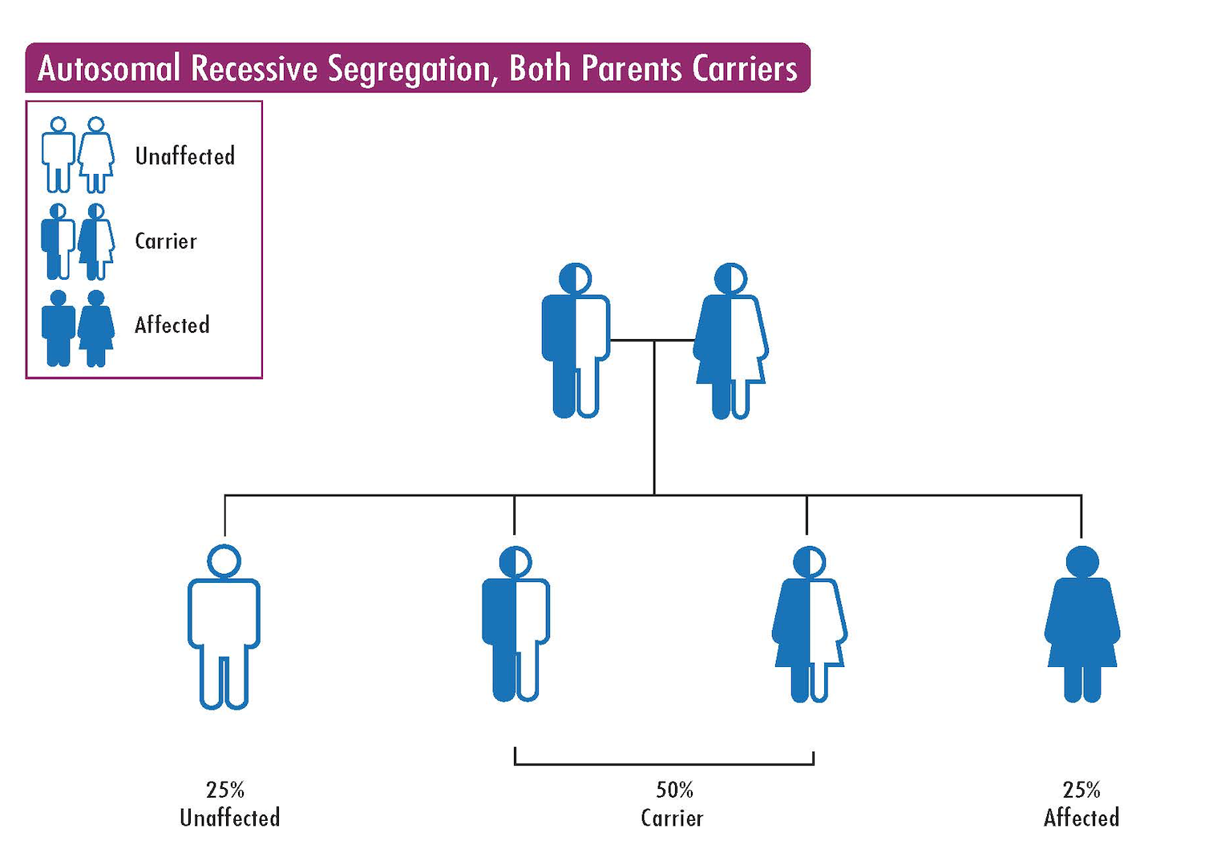
A carrier has one changed gene and one working gene, and is usually healthy. A recessive condition can occur if a child inherits the same changed gene from both the sperm and the egg. This pattern is called autosomal recessive inheritance. An example of a recessive condition you may have heard of is cystic fibrosis or thalassemias
Has a donor been screened for recessive conditions?
In the UK, guidelines require donors to be screened for some recessive genes that are common in certain ethnic groups.
New genetic tests can now screen for many recessive conditions at the same time. This is known as carrier screening. Many sperm and egg donor banks routinely offer carrier screening. Some screen for only a small number of conditions, while others screen for several hundred. This broader testing is called expanded carrier screening.
Carrier screening does not detect all genetic conditions. It also cannot find every genetic change.This means there is a small chance that a donor could still be a carrier even if the carrier screen result is negative.
You can ask the donor bank which recessive conditions a donor has been screened for. If a donor is found to be a carrier, this information should be shared with you.

What does it mean for a recipient if a donor is a carrier of a recessive condition?

Most people are carriers of one or more recessive genetic conditions. Being a carrier usually does not affect a person’s health. However, there may be a risk to a child if both a donor and a recipient are carriers of the same condition.
The level of risk depends on how common that carrier status is. For example, about 1 in 25 to 30 people of Northern European background carry a gene change linked to cystic fibrosis. If both the donor and the recipient are carriers of the same gene, there is a 1 in 4 (25%) chance that a child would be affected.
An individual’s chance of being a carrier can vary because some genetic changes are more common in certain ethnic backgrounds.
Most recipients do not know whether they are carriers of recessive conditions. If a
donor is known to be a carrier, it is possible to estimate the chance that a child could be affected. This estimate is based on how common the carrier status is. This is known as the carrier frequency..
For example, if your chance of being a carrier of the same gene as the donor is 1 in 25, the chance of having a child affected by the condition would be about 1 in 100 (1%). If your chance of being a carrier is 1 in 100, the chance of having an affected child would be about 1 in 400 (0.25%).
To put this into context, around 3 in 100 pregnancies in the general population are
affected by a congenital anomaly or disability.

Can I choose a donor who is a carrier of a recessive condition for my treatment?

There are many factors to consider when choosing a donor. If a donor is a carrier of a recessive condition, this does not usually prevent their use in treatment. Donor banks may ask you to sign a consent form to confirm that you have been given clear information about the donor’s carrier status.Your clinic or donor bank should be able to help you find the information you need.
NHS guidance on carrier screening suggests that people with a higher chance of being a carrier may be offered testing. If you are choosing a donor who is a known carrier, and your chance of carrying a change in the same gene is relatively high, it may be helpful to speak with a suitably qualified person about what this mean for you and options to screen yourself.
Some people feel comfortable proceeding with treatment after understanding their personal level of risk. Others may prefer to have carrier screening to find out whether they are also carriers of the same condition. Policies can vary between fertility clinics and donor banks, and everyone’s comfort with risk is different. Your clinic or donor bank should be able to help you access further information. This may include speaking with a healthcare professional with expertise in genetics, such as a genetic counsellor or another suitably qualified clinician, who can help you understand your personal carrier risk and options.
Carrier screening kits bought online are often not detailed enough for accurate screening of recessive conditions.
If a donor is a carrier of a recessive condition, there is a 50% chance that a child would inherit the altered gene and be a carrier themselves. This would not usually affect the child’s health, but it may be useful information for them when they are planning a family.

.

